**ECE 457**

**Fall 2019**

**Concept Design Review**

**ECE – 6 TV Auto Commercial Mute System (MuteBot)**

**Report Submitted: November 5, 2019**

We, the undersigned, certify that we contributed to the generation of this report and attest to the validity of the data herein:

**Team Members:**

Steven Ferreira _____________________

Thomas Morrissey _____________________

Kevin Prairie _____________________

Zachary Taylor _____________________

**Customer:**

Dr. Paul J. Fortier

**Advisor:**

Dr. David P. Rancour

**Table of Contents**

Abstract 4

1 Introduction 4

2 System Diagrams 4

3 Customer Requirements 6

4 Engineering Requirements 7

4.1 Constraints 9

5 Standards 10

6 Resource & Cost Summary 11

7 Assesssing Alternatives 12

7.1 Processors/Development Board 13

7.2 Interfaces 14

7.3 Remote Control 15

7.4 Programming Languages 16

8 Risk Analysis 18

9 Schedule 18

10 Earned Value 24

A Appendix 25

**List of Tables**

Table 1: Customer Requirements 6

Table 2: Customer to Engineering Requirements 7

Table 3: Resources Summary & Cost 12

Table 4: Processor/Development Board Comparison 13

Table 5: Processor/Development Board Strengths vs. Weaknesses 13

Table 6: Interfaces Strengths vs Weaknesses 14

Table 7: RF/IR Remote Control Decision Matrix 15

Table 8: Programming Languages Strength vs. Weaknesses 16

Table 9: Potential Problems & Risk Analysis 18

Table 10: Earned Value for the SRR and CDR 24

**List of Figures**

Figure 1: Functional Architecture Diagram 5

Figure 2: Top-Level System Diagram 6

Figure 3: System Requirements Review Schedule 19

Figure 4: Concept Design Review Schedule 20

Figure 5: Preliminary Design Review Schedule 21

Figure 6: ECE 457 Full Schedule Part 1 22

Figure 7: ECE 457 Full Schedule Part 2 23

# Abstract

The TV Commercial Auto-mute system, or MuteBot, is being created to combat the initial volume spike that commercials use to quickly grab the attention of a viewer. After meeting with the customer, it was agreed upon to allow for a 10 second buffer to improve detection accuracy of the system. Engineering requirements have been altered based upon changed customer requirements, feedback from the System Requirements Review, and additional research done by the team. Research has been done in order to best make decisions for crucial aspects of the system such as processor, TV interface, IR/RF Remotes, and programming languages. Each aspect has multiple different paths which each have their various strengths and weaknesses. Using the tradeoff tables made and prototyping to be done in the next phase, the team will be able to make educated decisions on the best plans of approach.

# Introduction

After using the feedback provided from the System Requirements Review, requirements, constraints, system diagrams, and other components have been updated and altered in order to show the progress that has been made. At this stage of the project, several decisions must be made for the subsystems and major components of the system. Alternatives for each major component had to be made, assessed, and compared to each other in order to evaluate the best approach. By narrowing down alternatives via decision matrices and strengths vs. weaknesses tables, they can be further narrowed down after prototyping during the PDR phase in order to chose the best possible alternative.

# System Diagrams

In Figure 1, a functional architecture diagram is used to give a full overview of the subsystems and components that will make up the full MuteBot system. The full system has been broken down into 3 main categories: Signal Processing & Volume Control, Mounting System, and the Remote Control. Within each subsystem includes different componenets and aspects needed to meet the customer requirements for the system.

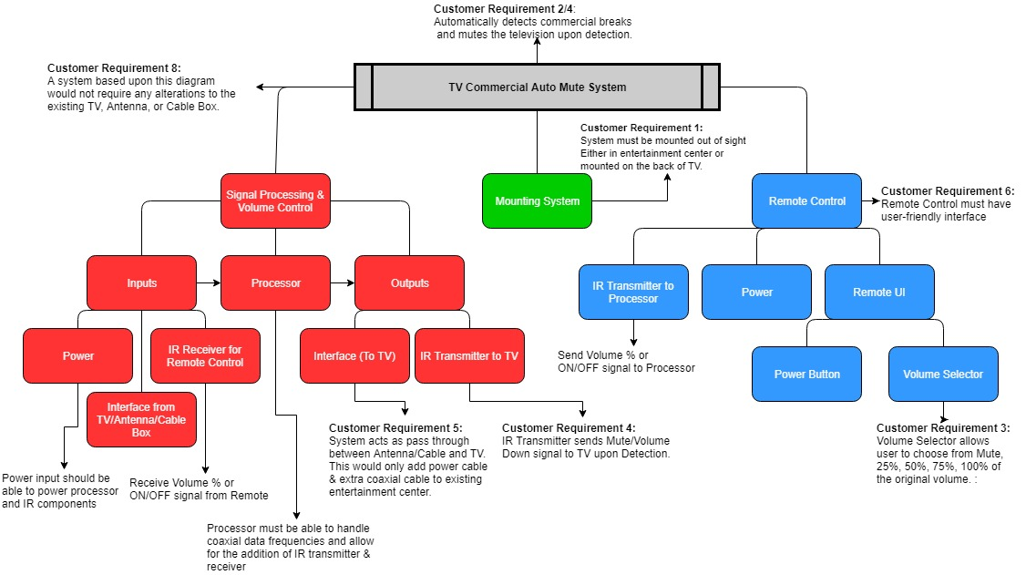Figure 1: Functional Architecture Diagram

The design displayed in Figure 2 is a top-level system design. This design gives a general external overview of the design project. It highlights where the system should connect into an existing entertainment center set-up as well as what each component in the system should be doing.

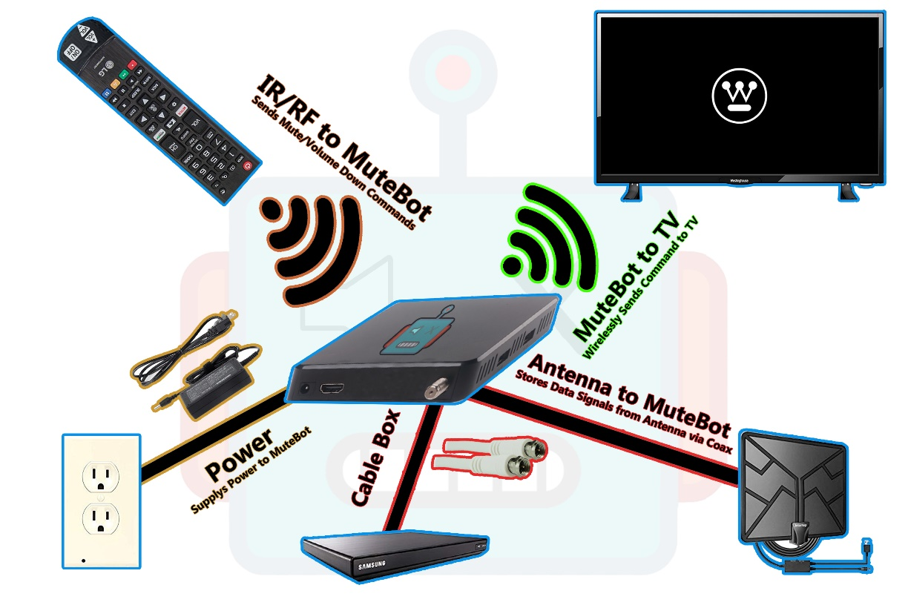

Figure 2: Top-Level System Diagram

# Customer Requirements

After meeting with our customer and proposing an added delay to the TV broadcast, requirement 2 was changed in Table 1. Allowing for a delay in the broadcast would assist in increasing the accuracy of the commercial detection program. The customer felt as though this was an acceptable tradeoff and it was agreed upon that there could be a 10 second delay to boost accuracy. All other requirements in Table 1 have stayed the same from the System Requirements Review.

Table 1: Customer Requirements

|  |  |
| --- | --- |
| Customer Requirement Number | Requirement Description |
|  | System must not obstruct the TV Screen. It must be able to be kept out of sight. |
|  | ~~System must be able to preemptively detect a commercial break and a return to the program.~~  System must appear preemptive to the user, but can delay the broadcast by 10 seconds for improvement of accuracy. |
|  | System must allow user to choose to mute completely or lower volume when a commercial is detected. |
|  | System must mute or lower volume upon break and unmute or return to original volume upon return. |
|  | System must be simple to initially set up. |
|  | System must have a user-friendly interface/remote. |
|  | System cost must be competitive with competition. |
|  | System must refrain from any alterations to the TV or its remote control. |

# Engineering Requirements

Table 2 takes the customer requirements described in Table 1 and breaks them down into quantifiable and testable engineering requirements. Due to the change in customer requirements, engineering requirement section 2 has been changed. The other major change is that a questionnaire, found in Appendix A, has been added to supplement the user-review. This will be quantified in a scoring format. If the system scores less than a 3 out of 5 in any category then this category will be the focus of improvement. The rest of the requirements remain the same as of present.

Table 2: Customer to Engineering Requirements

|  |  |  |  |  |
| --- | --- | --- | --- | --- |
| Rqmt. # | Customer Requirement | Engineering Requirement | Justification/Comments | Test Method (IADT) |
|  | System must not obstruct the TV screen. It must be able to be kept out of sight. | System can have a cable box at most, rest of system must remain behind the TV. | The system must not be obtrusive to ensure the user has a clear and not obstructed viewing experience. | Inspection:  User-Review/Observation  This will be measured via a questionnaire. Any category in the questionnaire labeled 3 or lower will be deemed not acceptable and the next step for improvement. |
|  | ~~System must be able to preemptively detect a commercial break and a return to the program.~~  System must appear preemptive to the user, but can delay the broadcast by 10 seconds for improvement of accuracy. | System must mute to 0 dB before at least 1 millisecond before commercial break appears before the user. | The system must mute preemptively in order to ensure a smoothing viewing experience for the user. | Test:  Use Audacity or other audio editing program to measure average decibel value over a time sample of 1 minute and time passed before mute was engaged. |
| 2.1 |  | System will delay the live broadcast by at most 10 seconds. | This delay allows for an increase rate of accuracy due to being able to have a larger sample size. | Test:  Use two different TVs, one with MuteBot Connected, one without MuteBot connected. Use a stopwatch to test the time difference between the same frame. |
| 2.2 |  | System must lower volume a percentage lower before at least 1 millisecond before commercial break appears before the user. | The system must abide by the user’s selection. | Test:  Use Audacity or other audio editing program to measure average decibel value over a time sample of 1 minute and time passed before mute was engaged. |
| 2.3 |  | When returning from break the TV must return to the original dB volume before the commercial break at least 1 millisecond before returning to the live show appears before the user. | The system shouldn’t alter the original programming at all as that is not the intent of the system and not preemptively returning the volume will result in a disturbance in the user’s experience. | Test:  Use Audacity or other audio editing program to measure exact decibel value and time passed after mute was disengaged. Measure average decibel value over a time sample of 1 minute after disengagement to ensure volume returned to original value. |
|  | System must allow user to choose to mute completely or lower volume when a commercial is detected. | The system must have a user interface that enables the user to choose between a volume of 0% (mute), 25%, 50%, 75%, 100% (off). | Giving options to the user allows for a more customizable experience. | Inspection:  Ensure quality of UI by user-review.  This will be measured via a questionnaire. Any category in the questionnaire labeled 3 or lower will be deemed not acceptable and the next step for improvement. |
|  | System must mute or lower volume upon break and unmute or return to original volume upon return. | System must lower the TV to 0 dB if that percentage is chosen. | The mute system is to ensure the user comfort by allowing the manipulation of volume. | Test:  Use Audacity to ensure the average decibel value over 3 minutes is 0 dB. |
| 4.1 |  | If lower volume is chosen the system must lower the TV’s volume by the percent chosen by the user. | Same as above. | Test:  Use Audacity to ensure the average decibel value over 3 minutes is the chosen value less than the measured programming volume. |
|  | System must be simple to initially set up. | The engineers are only to assume the users know how to: plug in an HDMI cord, | If the system is similar to design to a TV, then the user will find it easier to work with something of similar design. | Inspection/Demonstration:  User-Review/Test Subject  This will be measured via a questionnaire. Any category in the questionnaire labeled 3 or lower will be deemed not acceptable and the next step for improvement. |
| 5.1 |  | Power Cord, | Same as above. | Same as above |
| 5.2 |  | Interface with a TV remote | Same as above. | Same as above |
|  | System must have a user-friendly interface/remote. | The user interface must not consist of anything that would not already be on a TV remote or cable box. | A simple user interface allows ease-of-use and broadens the potential consumers. | Inspection/Demonstration:  User-Review/Test Subject  This will be measured via a questionnaire. Any category in the questionnaire labeled 3 or lower will be deemed not acceptable and the next step for improvement. |
|  | System cost must be competitive with competition. | The system must remain anywhere from $40 - $100 retail cost. | A low retail costs attracts more customers and makes the product more able for mass production. | Analysis:  Components and materials cost will be analyzed using Excel. The final product will be compared to competition (MuteMagic, MuTR) |
| 7.1 |  | Thus, the manufacturer cost is estimated to be between $24-$67. | A lower manufacturer costs aims for a larger profit. | Analysis:  Same as above. |
| 8. | System must refrain from any alterations to the TV or its remote control. | The TV and remote must remain the same as originally purchased. | Altering the TV or remote would require too much of the user and is not fit for mass production. | Inspection:  User-Review  This will be measured via a questionnaire. Any category in the questionnaire labeled 3 or lower will be deemed not acceptable and the next step for improvement. |

## Constraints

After the SRR report and presentation, feedback was given and some changes were needed. As shown in the list below, the form factor of the MuteBot system had to be changed. Originally, the MuteBot system was determined to be around the same size as a cable box. After realizing that if the system were to be mounted to the back of the television, a cable box form factor would be larger than what people might like. It was determined and confirmed with our customer and advisor that the MutBot system would be the same size or smaller than an Apple TV or Roku Ultra. The only other change to the constraints was adding the output devices on the television. Number 5 lists the outputs of the TV, which includes a digital optical audio cable and the 3.5mm jack. These two output devices could be implemented into the MuteBot system. If the television were to be muted or decreased in volume, the sound system with a digital optical cable or a 3.5mm jack would have to muted or have its volume decrease as well. The list below shows all of the contraints for the CDR with changes made in green text.

1. Form Factor (Same size or smaller than an Apple TV or Roku Ultra)

* Apple TV: Height-1.4 in, Width-3.9 in, Depth-3.9 in
* Roku Ultra: Height-0.8 in, Width-4.9 in, Depth-4.9 in

1. TV cannot be altered or changed in any way (Removing or modifying parts or remote)
2. Location- should not be visible (mounted to the back of the TV)
3. Inputs on the TV (HDMI, coax)
4. Outputs on the TV (Digital Optical Audio cable, 3.5mm Jack)
5. Budget-must be in same price range as the competitors (MuteMagic $39.95, MUTR $30 with a subscription of $50 per year)
6. Television provided (Westinghouse HDTV)

# Standards

Standards from the SRR were updated for the CDR. These changes include adding the standards for the HDMI cable, digital transmission, coaxial, power adapters, and IR and RF transmitter and receiver communication. The standards are shown in the list below with additions for the CDR in green text.

1. CALM Act: Commercial Advertisement Loudness Mitigation Act:
   1. <https://www.provideocoalition.com/the-calm-act-commercial-advertisement-loudness-mitigation/>
   2. The FCC set and monitor the loudness of commercials. The ITU, International Telecommunication Union, created standard audio measurements for content that is being broadcasted
2. ITU-R BS.1170:
   1. <https://www.itu.int/dms_pubrec/itu-r/rec/bs/R-REC-BS.1770-4-201510-I!!PDF-E.pdf>
   2. Ways to measure commercial audio loudness and true-peak audio level
3. IEEE Code of Ethics
   1. <https://www.ieee.org/about/corporate/governance/p7-8.html>
   2. The responsibilities in which all engineers are expected to follow that are expressed in a code of ethics.
4. Betamax Case: Sony Corp. of America v. Universal City Studios, Inc.
   1. <https://www.oyez.org/cases/1982/81-1687>
   2. Ruled recording TV legal
5. Copyright Laws and Television:
   1. <https://yourbusiness.azcentral.com/copyright-laws-television-16286.html>
   2. TV cable programs have copyrights to a program that can be violated (file sharing and sales, dependent on each program)
6. HDMI Specification Version 1.4a
   1. https://www.hdmi.org/manufacturer/hdmi_1_4/index.aspx
   2. HDMI standards and specifications that define the required waveforms and video format.
7. American National Standard ANSI/SCTE 07 2006, American National Standard ANSI/SCTE 124 2006
   1. <https://www.scte.org/documents/pdf/Standards/ANSISCTE072006.pdf>
   2. Digital Transmission Standard for Cable Television
   3. <https://www.scte.org/documents/pdf/Standards/ANSISCTE1242006.pdf>
   4. Specifications and standards for the F type connector used for cable television
8. ITU-T L.1002 (10/2016)
   1. https://www.itu.int/itu-t/recommendations/rec.aspx?rec=12131
   2. Standards for external universal power adapters
9. Standard IEC958
   1. Digital audio interface, standard for digital optical audio cables
   2. <http://www.epanorama.net/documents/audio/spdif.html>
10. TRRRS Standards including P.382
    1. Standards for the 3.5mm connector
    2. P.382 TRRRS connectors for new integration including multiple sources and noise canceling
    3. https://www.itu.int/itu-t/workprog/wp_item.aspx?isn=9990
11. Infrared Data Association (IrDA)
    1. Standards and specifications for IR transmitter and receiver communication
    2. <https://www.novell.com/documentation/suse91/suselinux-adminguide/html/ch08s03.html>
12. IEEE 802.15.4-2015 - IEEE Standard for Low-Rate Wireless Networks
    1. Standard for RF modules including the 3 pin RF module
    2. Short range devices have unlicensed ISM/SRD bands like RF remotes
    3. <https://standards.ieee.org/standard/802_15_4-2015.html>

# Resource & Cost Summary

The resources and cost for the project were updated to include the cost for a new development board and different television input and output components. The BeagleBone Black was added to Table 3 as shown below. The BeagleBone Black was given by the customer to give an alternate solution to the design of the MuteBot system. After feedback from the SRR, equipment and software costs were updated as well. N/A was not the correct cost explanation and it was changed to be provided by either the university or by the customer. The RF transmitter and receiver were added to Table 3. This was done because the communication between the auto-mute system and the television can be completed with IR or RF transmission. Table 3 highlights some of the components and software needed for prototyping in the next phase of the project. The total cost will change depending on which components we decide to use for prototyping.

Table 3: Resources Summary & Cost

|  |  |
| --- | --- |
| Resource | Cost |
| Custom PCB | $50.00 |
| BeagleBone Black | $56.96 |
| ATmega328PB chip | $1.26 |
| Raspberry Pi 4 | $48.00 |
| 5V DC Power supply | $9.00 |
| IR Transmitter & Receiver | $6.98 |
| HiLetgo 315Mhz RF Transmitter and Receiver Module | $4.69 |
| Coax cable | $4.82 |
| 3.5mm jack | $6.99 |
| Digital optical audio cable | $5.56 |
| Westinghouse HDTV & Remote | Provided by customer |
| PCB Fabricator | Supplied by Umass Dartmouth |
| TV Antenna | Provided by customer |
| HDMI Cable | Supplied by customer |
| 3D Printer | Supplied by Umass Dartmouth |
| Eagle Schematic & PCB Design | Software provided by Umass Dartmouth |
| Atmel Studio 7.0 | Software provided by Umass Dartmouth |
| Audacity | Free software |
| Solidworks | Free software |
| Total | $194.26 |

# Assesssing Alternatives

For the MuteBot system, there are multiple major components that have different solution paths. Those alternative solutions have been evaluated and compared to one another in order to narrow down the best solution paths to best meet the project’s customer and engineering requirements. Major aspects of the project include the processor/development board, TV interface, remote control, and programming language. Each of these aspects have different risks associated with them based upon the impact they have on the system as a whole.

## Processors/Development Board

Table 4 provides the overview of alternatives for choosing the processor/development board used to store audio and video data and send signals to mute/decrease the volume of the tv or sound system during a commercial. The systems below include the ATmega328pb Xplained mini, BeagleBone Black, Raspberry Pi 4 Model B(2GB), and a custom PCB with the ATmega328pb chip.

Table 4: Processor/Development Board Comparison

|  |  |  |  |  |
| --- | --- | --- | --- | --- |
| Processor/Development Board | ATmega328pb Xplained mini | BeagleBone Black | Raspberry Pi 4 Model B (2 GB) | Custom PCB design with ATmega328pb chip |
| Processor Speed | 20 MHZ | 1 GHz | 1.5 GHz | 20MHZ |
| Power | 1.8-5.5V DC  or USB | 5V DC or USB | USB C 5V DC | 5V DC or USB |
| DDR Memory | 32 KB | 512 MB | 2GB LPDDR4 | 32 KB |
| Cost | $9.26 | $56.96 | $48.01 | $51.26 |
| Connection | 32 interface pins | 92 connection points | 40 dedicated interface pins | 32 interface pins |

Table 5 describes the strengths and weaknesses of each system. This helped determine which system was best suited for the team’s project and best met the customer and engineering requirements.

Table 5: Processor/Development Board Strengths vs. Weaknesses

|  |  |  |
| --- | --- | --- |
| Processor/Development Board | Strengths | Weaknesses |
| ATmega328pb Xplained mini | * Cost * Familiar (ECE 263) * Programming languages (Atmel Studio for C, C++, Assembly) * Form Factor | * Speed in order to receive high frequency audio and video waveforms * Memory in order to store data * Connections- lowest amount at 32 |
| BeagleBone Black | * Expandable hardware with 92 pins * On board storage- 4GB * Expandable storage – microSD card * Speed- 1GHz * Programming languages (Python, C, C++) | * Form Factor * Cost * Speed- will depend on how fast it needs to be to capture coaxial/HDMI signals |
| Raspberry Pi 4 Model B (2 GB) | * Speed- 1.5 GHz * Memory * Storage- expandable storage with microSD card * Interfaces- HDMI, USB * Programming languages (Python, Scratch, C, C++) | * Cost * Runs on Linux but Windows can be installed * Form Factor- largest development board |
| Custom PCB design with ATmega 328pb chip | * Prioritize ATmega chip use and speed to focus on video and audio detection and analysis * Components needed for the PCB can be limited to only needed I/O (IR/RF receiver and transmitter, coaxial/HDMI input, audio output) | * Cost- includes $50 PCB, Atmega chip, 5V power adapter, labor to build * Time- more time to create PCB with risk of failure * Speed- will depend on how fast it needs to be to capture coaxial/HDMI signals |

Based upon the engineering requirements, in order to receive high frequency video and audio signals, a high-speed chip will be needed to perfom the task. With speed being the number one concern, the ATmega328pb Xplained mini will be deleted from the possible board that is used. As referenced in Table 4, the speed of the ATmega328pb was 20 MHz. This speed would not be enough to receive vido and audio signals, process them, and send the proper mute/decrease volume command to the television before a commercial is played. Using cost as a customer requirement, a low cost auto-mute system would be ideal. This would eliminate the custom PCB design due to both the lower processor frequncy and the amount of money needed manufacture the PCB. This price would also have to include the power adapter, processor, the PCB itself, and the labor required to design the PCB. This price would also increase if revisions were needed to the design. With two alternatives remaining, the chosen processor/development board will have to be decided before the preliminary design review. More research and prototyping needs to be completed in order to determine which processor is the most suitable for application. The amount of memory and storage needed to collect the required data is also still unknown. As of now, with the overall speed, memory, and expandable storage of the Raspberry Pi 4 Model B (2 GB), this board seems to meet the customer and engineering requirements. A final decision for each alternative will be made before PDR.

## Interfaces

Table 6: Interfaces Strengths vs Weaknesses

|  |  |  |
| --- | --- | --- |
| Interfaces | Strengths | Weaknesses |
| HDMI | * Produces both audio and video on one cable * Universally available (Standard for TV) | * Highly Encrypted via HDCP * Fast Transfer Speeds (10 to 18 Gbps for 4k) * Would require large memory capacity |
| Coax | * Universal (Works for antenna and cable box) * Produces both audio and video * Slow Transfer Speed (10Mbps) | * Cost (Would require a coax splitter) * Encryption via the cable provider |
| 3.5mm Audio Jack | * No Encryption * No Transfer Speeds (Works on Audio Frequencies) | * Only Audio Signals * Not Universal (Many TVs do not have one) |
| Digital Optical Audio Cable (TOSLINK) |  | * Encrypted * Not Universal * Only Audio Signals * Expensive to implement * 125 Mbps transfer rate |

Table 6 describes the strengths and weaknesses of each available interface for the system. The current choice for the system is a coaxial cable due to the strengths listed. TOSLINK has no strengths and does not offer anything that the other interfaces do not have. HDMI is a close second to coaxial, however the transfer speeds of HDMI are far faster than coaxial, which would raise the cost of a processor significantly. The biggest challenge with coaxial is the encryption via the cable provider. However, if a cable box is used the signal can not be encrypted while transferring via the cable. HDMI uses high-bandwith digital content protection (HDCP). This makes using this interface much more difficult as the system would have to pass an authenticity check. With coaxial, this can be avoided as the decryption process is a lot simpler. With 3.5mm audio jacks the biggest advantage is their lack of encryption and lack of transfer rates. This will allow ease of processing, but it lacks video signals which will result in less accuracy.

## Remote Control

Table 7: RF/IR Remote Control Decision Matrix

|  |  |  |  |  |
| --- | --- | --- | --- | --- |
| Criteria | Requirement | Weight | RF | IR |
| Cost | **7:** manufacturing cost between ($24-$67) | .2 | $4.69  (1) | $1.78  (2) |
| Range | Desired: 10m | .1 | 20-200 meters away from mute box  (1) | 20 meters away from mute box  (1) |
| Interference | **1:** Box can be placed behind the TV | .2 | No, interference for RF  (2) | Yes, interference between remote and box will prevent operation  (0) |
| Interface | **3:** Volume levels/mute can be turned on/off | .2 | The RF can be interfaced with the Raspberry pi  (2) | The IR sensors can be interfaced with the Raspberry pi  (2) |
| Remote Control | **8:** Remote control gets no physical altercations | .2 | No protruding LED is needed to change TV volume settings  (2) | Protruding LED must be added onto controller in order to change volume settings  (1) |
| Voltage | Desired: 5V | .1 | 5V  (1) | 5V  (1) |
| Total |  | **1** | **1.6** | **1.2** |

Table 7 provides the decision matrix that compares radio frequency communication with infrared communication. This part of the system is not as much of a priority when it comes to functionality, thus the weights for each requirement are relatively the same. RF communication not as cost effective as IR communication. Therefore, for a higher profit margin IR should be implemented. Both alternatives met the desired range requirement for the remote. Within requirement 1 it was stated that the mute box must be placed out of sight. IR sensors, though, require line-of-sight in order to transmit and receive data, however a compromise can be made to make an enclosure that is appealing in order to implement the cheaper IR communication. The RF detectors however do not need a line-of-sight to receive data, but at a higher cost. Both the RF sensors and the IR sensors could work directly with the Raspberry pi. The customer requested that nothing should be altered with the original TV system. Both can be implemented without alteration to the original TV system, however RF will not need an IR LED, thus being easy for implementation. The final value put into consideration for this matrix is the voltage that the two different sensors are powered at. Both sensors are powered at 5 volts, thus are weighted equally. Based upon the results found in Table 7, the team will begin prototyping with an RF remote control to further determine that it is the best plan of approach.

## Programming Languages

Table 8: Programming Languages Strength vs. Weaknesses

|  |  |  |
| --- | --- | --- |
| Programming Language | Strengths | Weaknesses |
| C/C++ | * All team members have experience with the language. * Able to do signal processing. * Language can be sued on all potential processors. | * Complex syntax, easy to make mistakes. * Audio/Image processing do not seem to be easy to work with. |
| Python | * User-friendly, easy to learn. * Simplistic syntax. * Libraries and packages for audio, image, and signal processing. * Can be run on BeagleBoard & Raspberry Pi * Have previous experience using it. | * Uses indentation for syntax which can create problems. * Unable to run on ATmega328p, needs underlying OS (requires interpretor). |
| Java | * Able to do audio, image, and signal processing. * Can be run on BeagleBoard & Raspberry Pi. | * Steep learning curve. * Members do not have previous experience. * Unable to run on ATmega328p, needs underlying OS (requires interpretor). |
| MATLAB | * All team members have experience with the language. * Able to do audio, image, and signal processing. | * Unable to run on ATmega328p * Unfamiliarity with audio, image, signal processing. Research shows there is a steep learning curve for those applications. * Does not have full support for BeagleBoard or Raspberry Pi |

Table 8 provides an overview of the strengths and weaknesses of the options the team has for a programming language to be used for the commercial detection program. Based upon the strengths and weaknesses of each, the team feels as though C/C++ or Python will be the best languages to prototype with in the next phase of the project. Based upon the prototyping done, the best option from the two will be used going forward into next semester.

# Risk Analysis

Table 9 provides an overview of the risk and potential problems that are related to each of the major components of the overall system. As the project moves forward, these risks will be altered based upon any new major decisions that need to be made during the Preliminary Design Review phase of the project.

Table 9: Potential Problems & Risk Analysis

|  |  |
| --- | --- |
| Potential Problems | Risk Factor |
| Choosing the incorrect processor/development board. | **High Risk**   * Increase time and cost to change design. * Effects other major components. |
| Choosing the incorrect programming language | **Medium Risk**   * Increase time and cost to change code for implementation * Time to learn new programming language if there is a steep learning curve |
| Choosing the incorrect TV interface | **Medium Risk**   * Increase time and cost to change design * Would effect detection program (input signals for detection) |
| Choosing the incorrect remote technology | **Low Risk**   * Increase time to change remote design * Both alternatives are compatible with all potential processors. |

# Schedule

Figures 3-5 provide an updated schedule for each progress report for the semester. Each task is broken down into a task name, in blue, and the criteria to complete the task, in green. Each task also has estimated hours to complete, estimated cost, actual hours & cost, team member responsible, and the percentage of the task complete. If the task has an engineering requirement associated with it, it is also listed in a separate column.

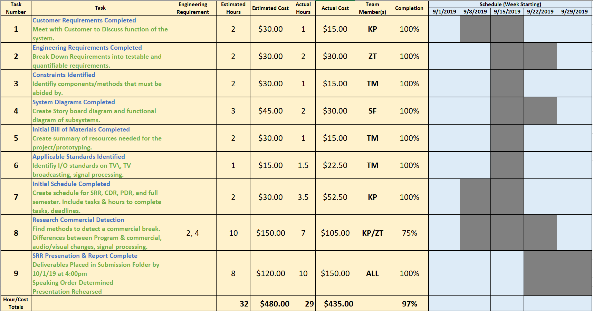Figure 3: System Requirements Review Schedule

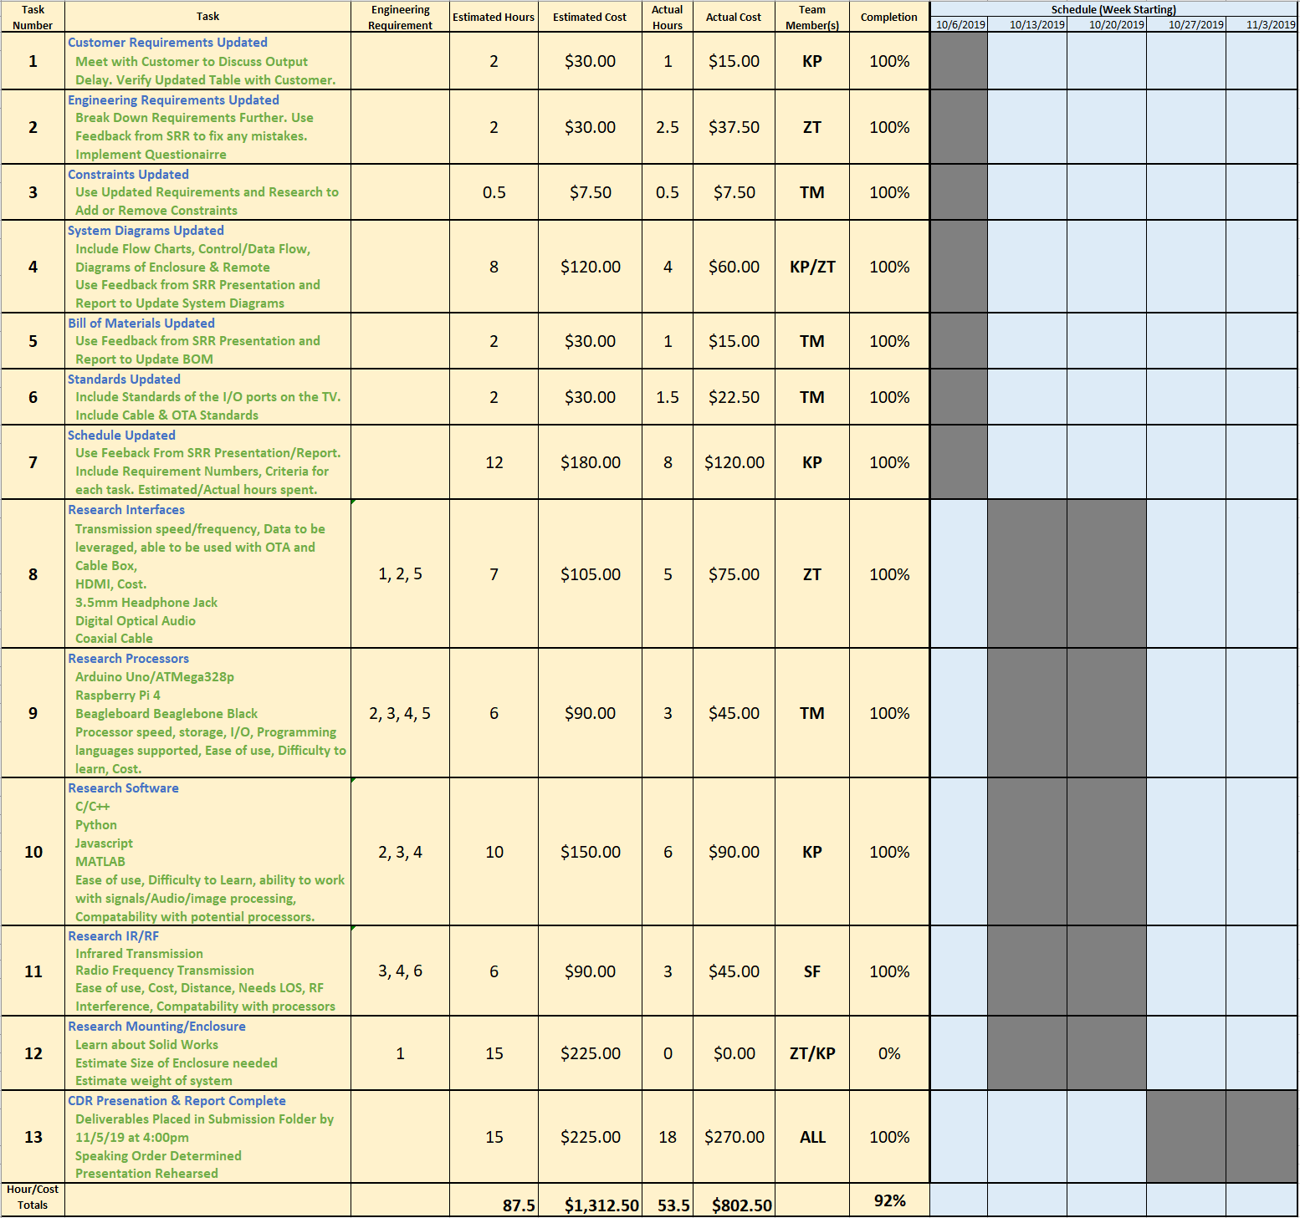Figure 4: Concept Design Review Schedule

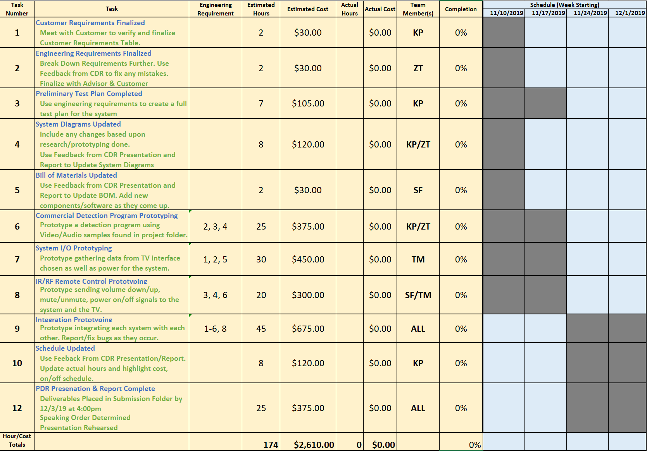Figure 5: Preliminary Design Review Schedule

Figures 6-7 combine the three schedules into an overall plan for ECE 457. This plan as been updated along with the other three schedules. The team feels as though it is best to make a plan that does not include work over the winter break because the likelihood of major tasks getting done while on break is low. Rather, based upon this schedule, any work done during the break would be seen as a bonus rather than a requirement. During the semester the team plans to meet weekly on Fridays at 10:00 AM. Advisor meetings with Dr. Rancour will also occur weekly on Wednesdays at 10:00 AM. If members are not able to attend, available members will still meet and discuss the progress made within the week and plan for the following week.

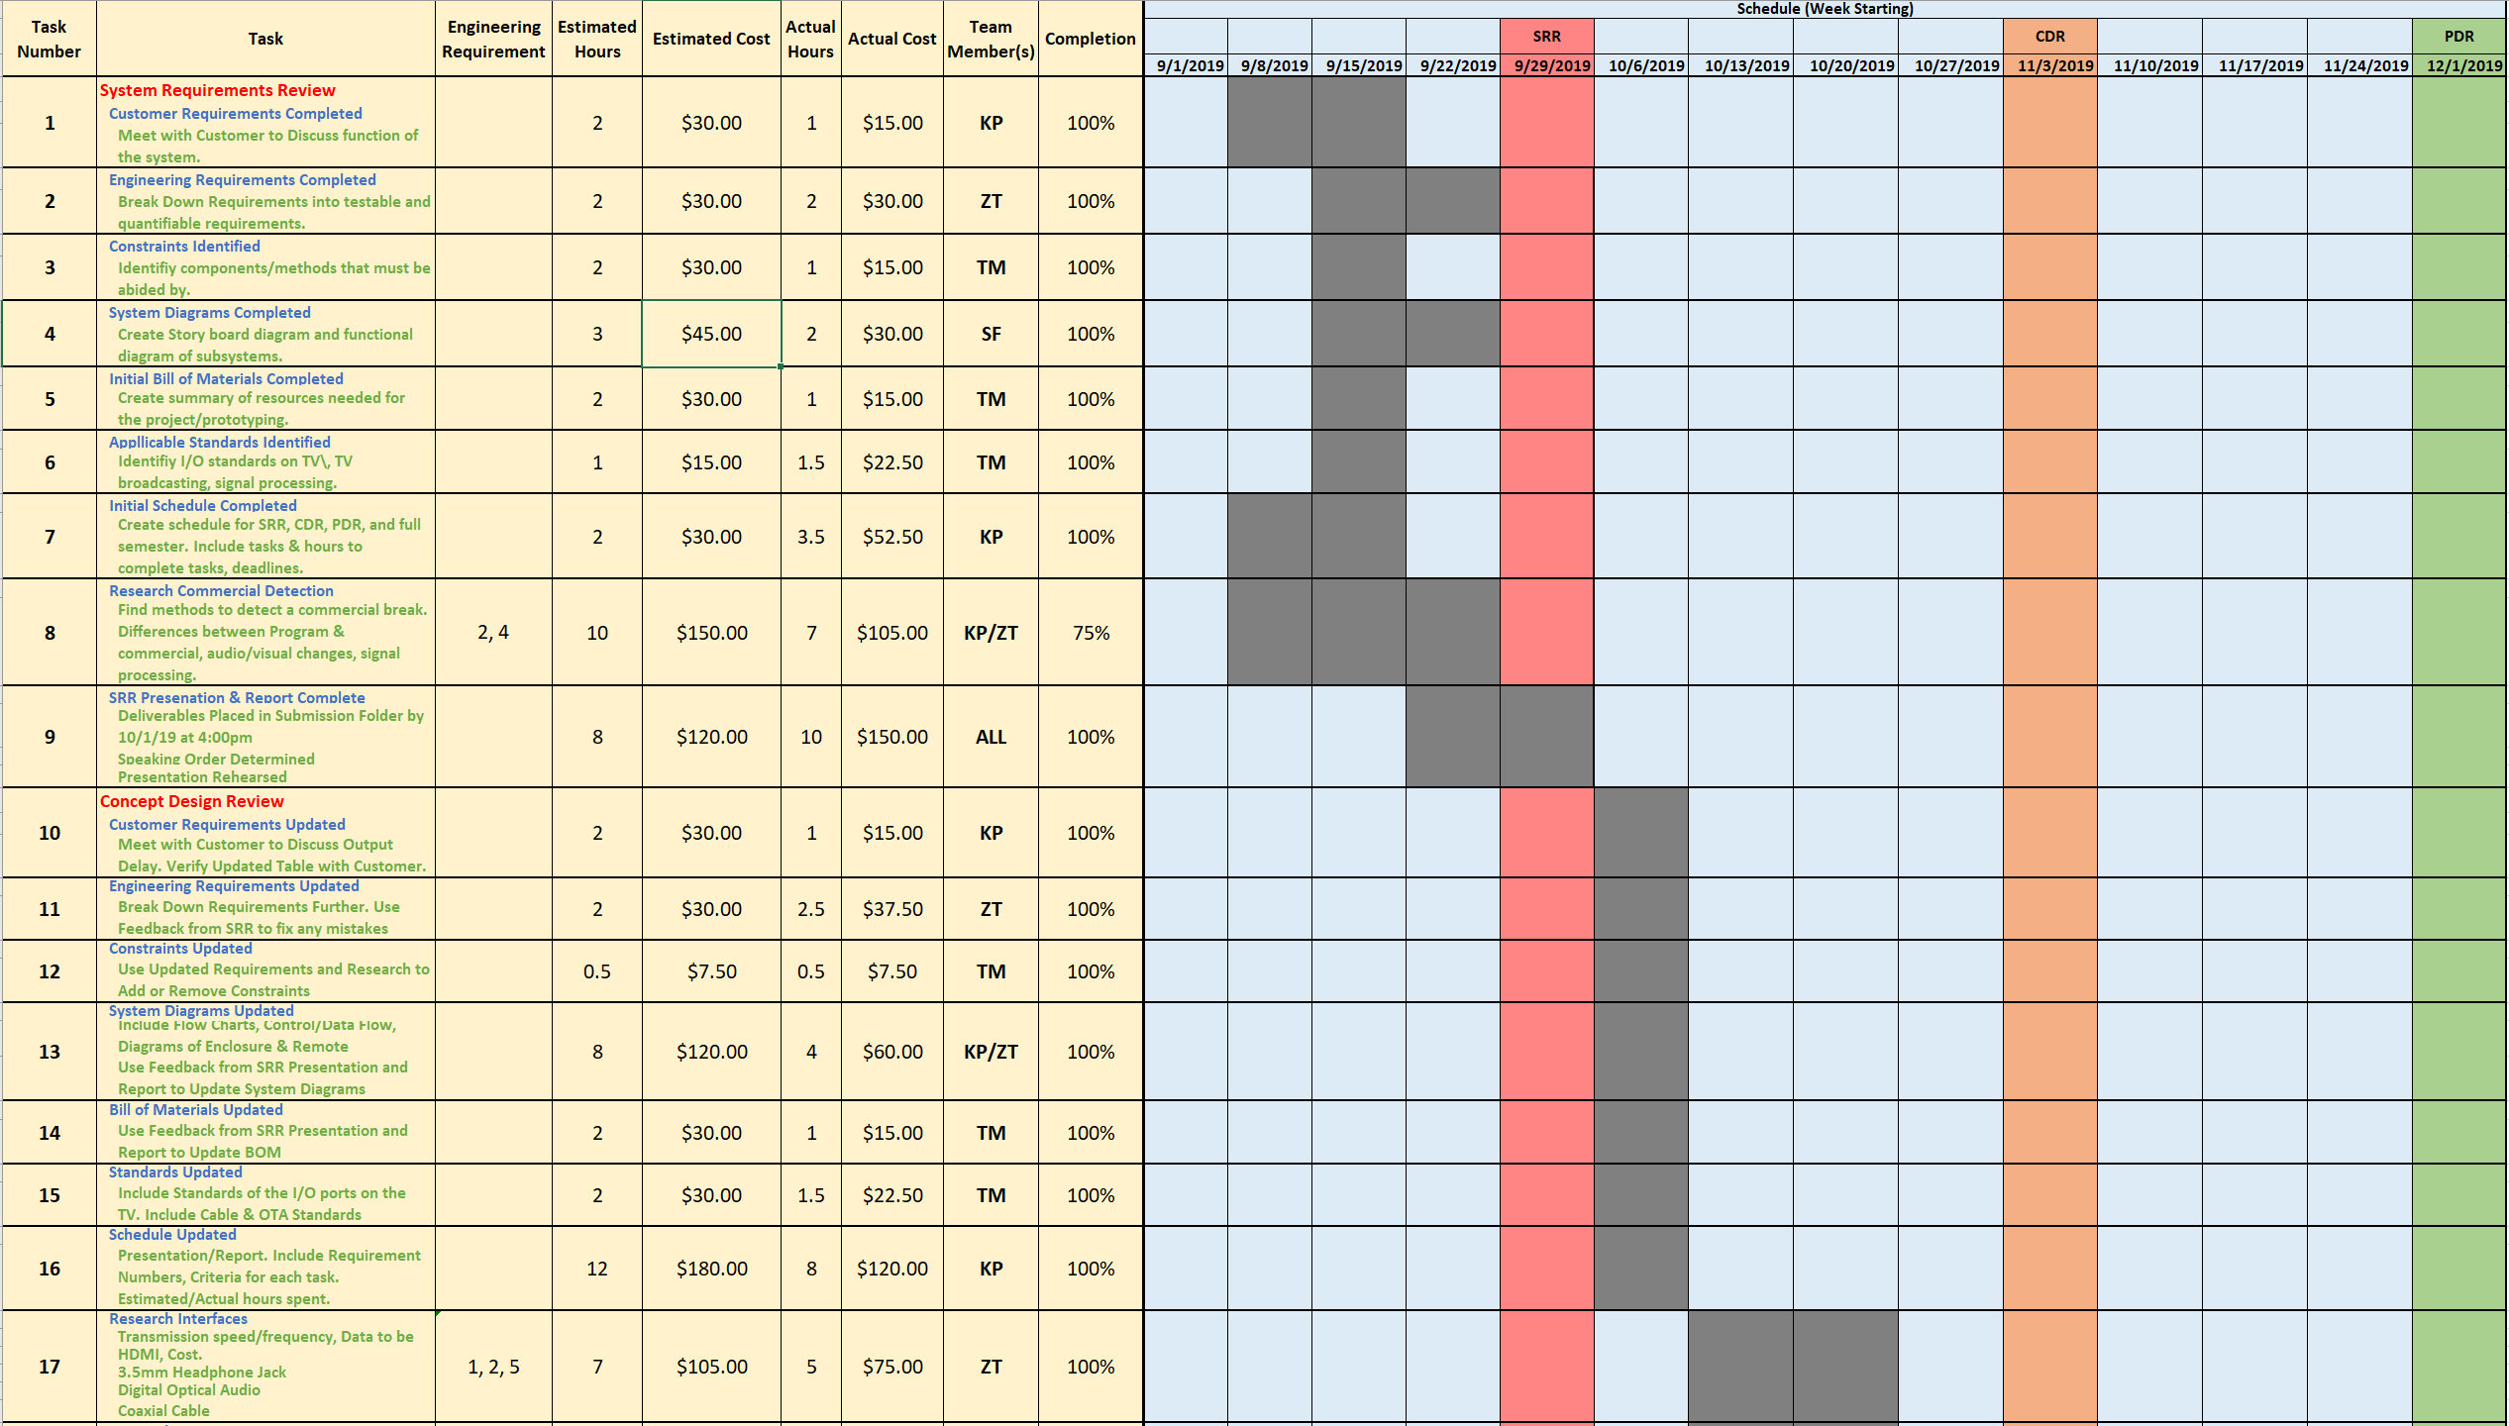**Figure 6: ECE 457 Full Schedule Part 1**

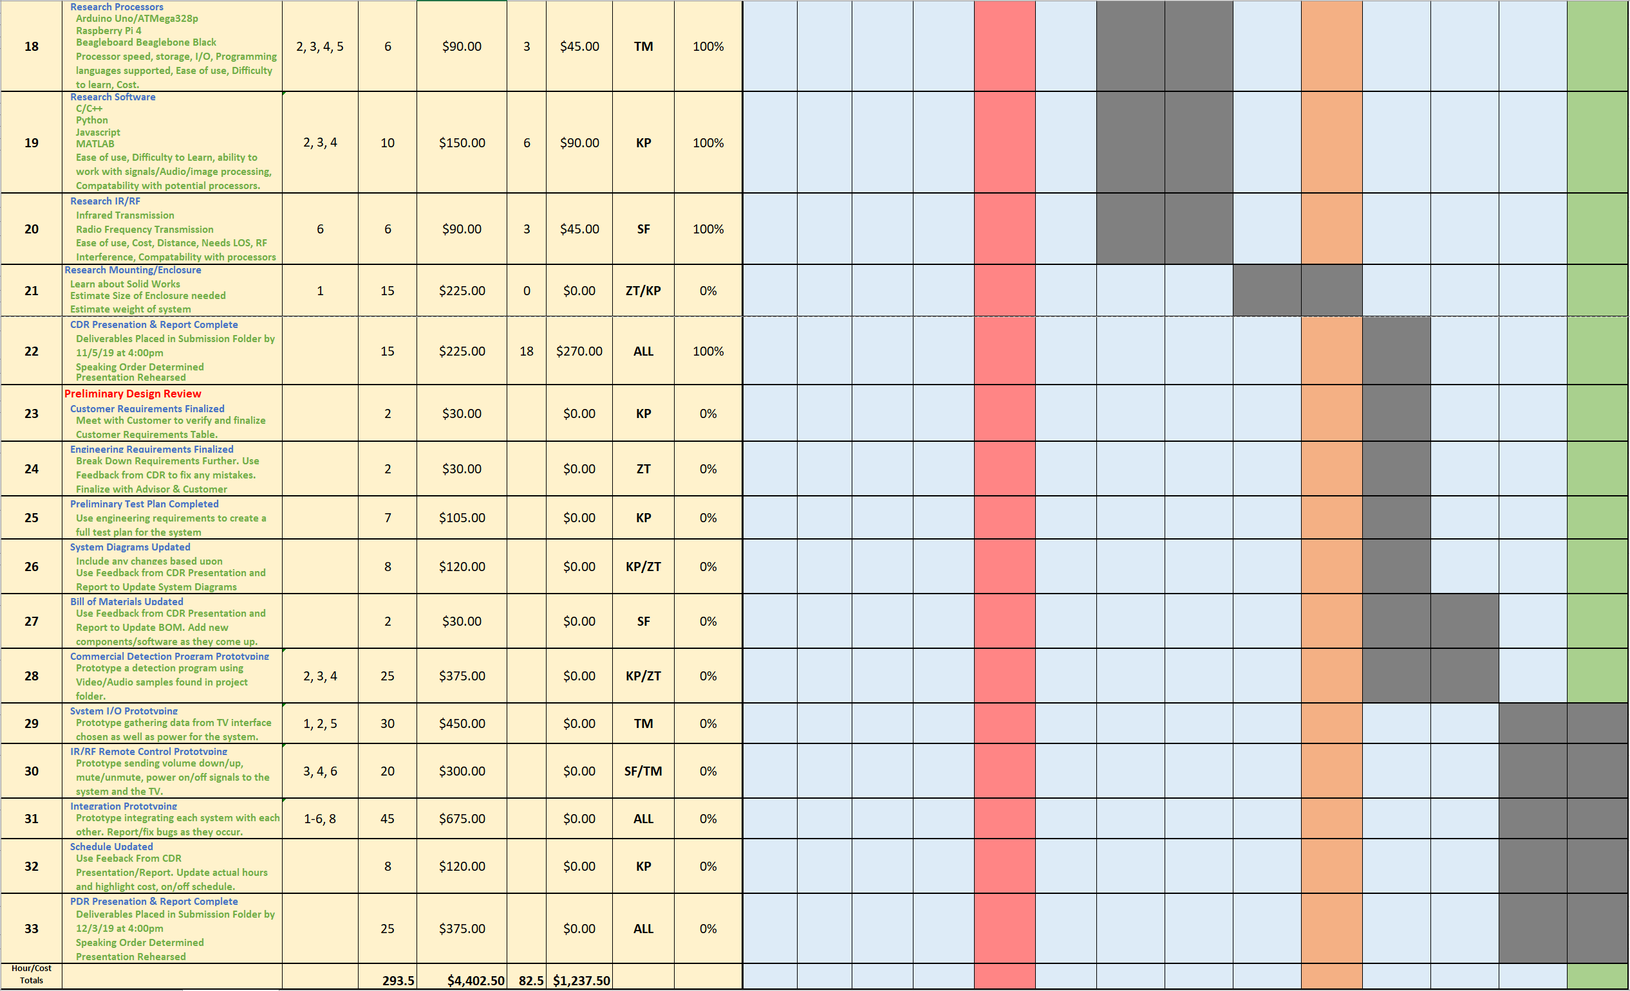Figure 7: ECE 457 Full Schedule Part 2

# Earned Value

Table 10 provides the estimated and actual hours and cost for the tasks of the SRR and CDR. In Table 10, the SRR had a completion percentage of 97% with the cost being below budget. This shows that for the SRR, the team was slightly behind schedule but below the estimated cost. The CDR earned value is also shown in the table below. The completion percentage of the CDR was 92% with the actual cost being below budget. These values describe that the team is again, slightly behind schedule but below budget.

Table 10: Earned Value for the SRR and CDR

|  |  |  |  |  |  |
| --- | --- | --- | --- | --- | --- |
| Tasks | Estimated Hours | Estimated Cost | Actual Hours | Actual Cost | Completion % |
| SRR | 32 hrs. | $480 | 29 hrs. | $435 | 97% |
| CDR | 87.5 hrs. | $1,312.50 | 53.5 hrs. | $802.50 | 92% |

**ECE 457**

**Fall 2019**

**Concept Design Review**

**ECE – 6 TV Auto Commercial Mute System (MuteBot)**

### **Appendix**

